* How to get the List of Commands in Power Shell?
* Get-Command
* How to get the Module Path of Power Shell?
* $env:PSModulePath
* How to get Home Directory in Power Shell Console?
* $PSHome
* How to get Power Shell Version in Power Shell Console?
* $PSVersionTable
* How to get the Windows Services List Installed in Power Shell Console?
* Get-Service
* How to get the Process list in Power Shell Console?
* Get-Process
* How to get the list of Modules in Power Shell Console?
* Get-Module
* How to get the list of Installed Modules in PowerShell Console?
* Get-InstalledModule
* How to get the Date in Power Shell Console?
* Get-Date
* How to get the Local Users details in Power Shell Console?
* Get-Localuser
* How to get the Local Group details in Power Shell Console?
* Get-LocalGroup
* How to get the members details of a specific Local Group?
* Get-LocalGroup –Group [Group Name]
* 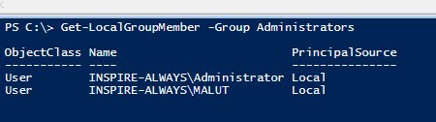
* How to get the Computer Name from PowerShell Console?
* HOSTNAME or $env:ComputerName